Lab 03: Enum

In order to assign a value into ENUM inputs, we do the following:

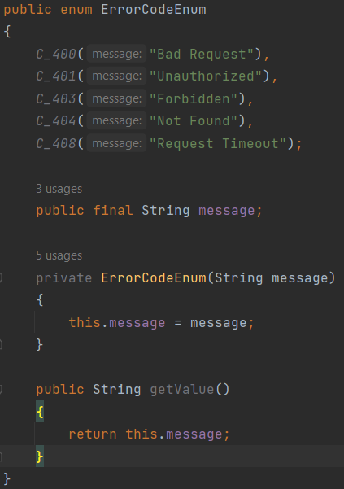

In order to extract the values using enum in the main function, we do the following:

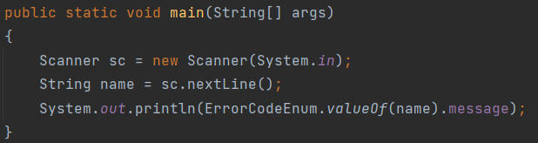

Lab 04: Unit testing

Using the bottle of bear song and the shape problem, we saw how to test verses of lines of the song using unit testing.

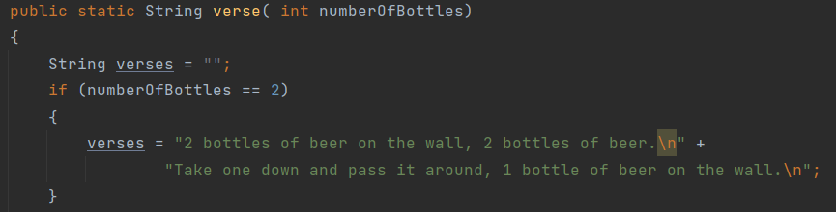

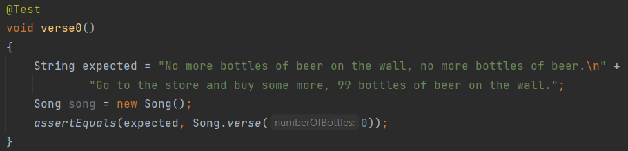

Lab 05: Generics